In your responses to your classmates, address the following:
- Share at least one thing you learned from their post or one thing you found interesting about their post.
- Provide at least one information-based resource (video or article) in each of your reply posts to further explore your classmate's topic. Be sure to briefly explain what you are contributing and why you are sharing it. Provide a link to the resource or embed the video.

Response Post:
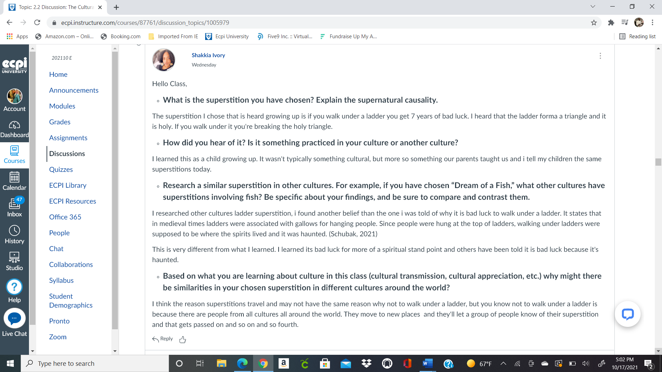

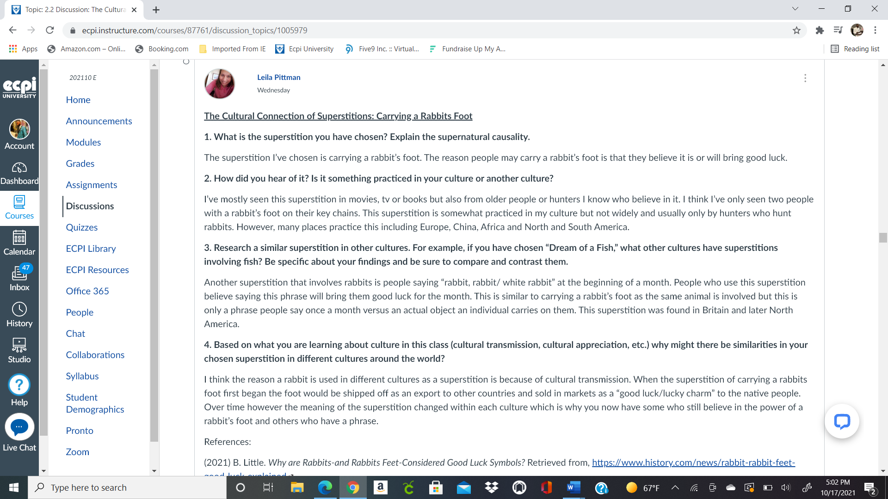

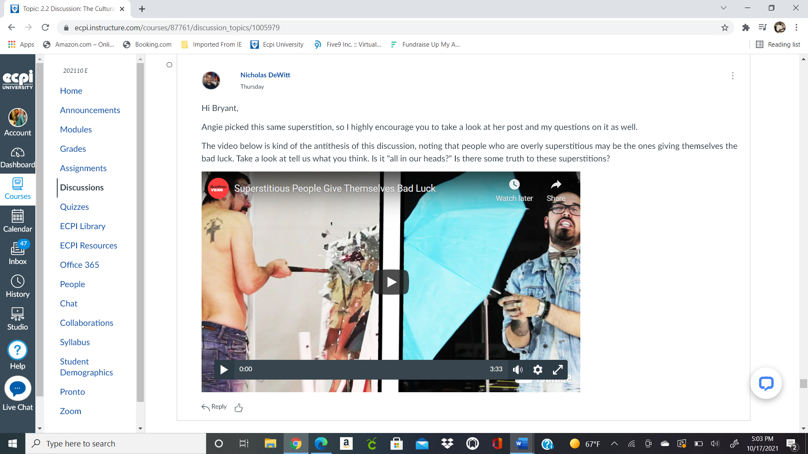
Must watch vdeo…

